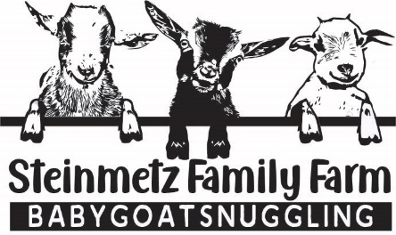
Available Goats
(Updated: 2/25/25)

Goat | Sex | Age | Breed | Price | Availability
Olivia  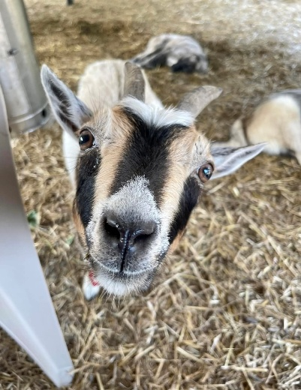 | F | 4 yrs | ND | $100 | RESERVED
Bonnie Lee  Photo to come | F | 5 yrs | ND | $100 | Now  Notes: Cannot be  Bred. Has issues  Kidding.
Allie  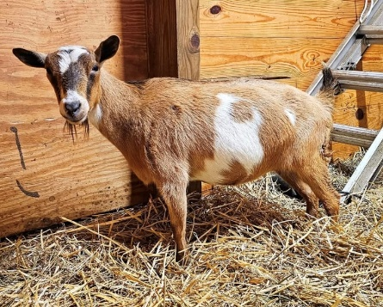 | F | 4 yrs | ND | $50 | Now  Notes: SPECIAL  CARE GOAT.  Allie had  meningeal worm  & will sometimes  drag her back  legs as a result.  Needs a quiet  farm, preferably  with Willow as  they are besties.  Should not be  bred.
Willow  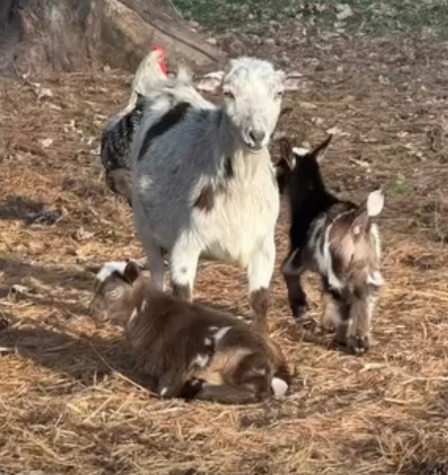 | F | 3 yrs | ND | $50 | Now  Notes: SPECIAL  CARE GOAT.  Willow had  meningeal worm  & will sometimes  drag her back  legs as a result.  Needs a quiet  farm, preferably  with Allie as  they are besties.  Should not be  bred.

